

ມະຫາວິທະຍາໄລແຫ່ງຊາດ

ຄະນະວິສະວະກຳສາດ

ພາກວິຊາ ວິສະວະກຳຄອມພິວເຕີ

ວຽກບ້ານວິຊາ: MPC & MCU

ສອນໂດຍ: ອຈ ນ. ລັດທິດາ ຄົມສອນລະສິນ

ຊື່ ແລະ ນາມສະກຸນ: ທ. ບຸນປະສົງ ວິລະນົນ

ລຳດັບ: 02

ລະຫັດນັກສຶກສາ: 225N0002/23

ຫ້ອງ: 3 com 1

ສົກສຶກສາ 2025-2026

**Arduino Starter Kit Numbered Checklist**

* **Core Boards & Interfaces**

- Arduino UNO board is the m**ain microcontroller board** (ATmega328P); It is used to upload and run code, control sensors, LEDs, motors, etc. and connects to your computer via USB.

- Breadboards are the boards for **building circuits without soldering. They are u**sed to test wiring, connect components, and prototype quickly.

- USB Cable: connects Arduino UNO to your PC for uploading code and powering the board.

* **Wiring & Connectors**

**+ Jumper wires:**

Jumper wires are used for **connecting components** on a breadboard or to Arduino pins. Jumper wires have 3 types:

- Jumper wires (male-to-male): used to connect between breadboard to breadboard.

- Jumper wires (male-to-female): used to connect between Arduino pin to module.

- Jumper wires (female-to-female): used to connect between module to module.

- 9V Battery Connector is used to power Arduino **when not connected to a computer**.

* **Basic Components**

**+ LEDs (Red: 5, Green: 5, Blue: 5, RGB: 1):**

- LEDs emit light when current flows and they are used for indicators, displays, or testing digital outputs.

- RGB LED is the LED that combines red, green and blue to produce various colors.

- RGB module is an easier-to-use RGB LED on a small board, each color pin is separately controllable.

**+ Resistors (220 Ω, 1 kΩ, 10 kΩ):**

Resistors is a [passive](https://en.wikipedia.org/wiki/Passivity_(engineering)" \o "Passivity (engineering)) [two-terminal](https://en.wikipedia.org/wiki/Terminal_(electronics)" \o "Terminal (electronics)) [electronic component](https://en.wikipedia.org/wiki/Electronic_component" \o "Electronic component) that implements [electrical resistance](https://en.wikipedia.org/wiki/Electrical_resistance" \o "Electrical resistance) as a circuit element. In electronic circuits, resistors are used to reduce current flow, adjust signal levels, to [divide voltages](https://en.wikipedia.org/wiki/Voltage_divider" \o "Voltage divider), [bias](https://en.wikipedia.org/wiki/Biasing" \o "Biasing) active elements, and terminate [transmission lines](https://en.wikipedia.org/wiki/Transmission_line" \o "Transmission line), among other uses. Resistors have 3 types:

- Resistor 220Ω is the resistor that used for LEDs.

- Resistor1kΩ is the resistor that uses for sensors/buttons.

- Resistor10kΩ is the resistor that uses for pull-up/pull-down configurations.

- Push bottons (×4 with Lids) are used as **input switches** (e.g., start, stop, reset).

- Potentiometer (5 kΩ) is one of the resistors that used to control **brightness, volume, or sensor sensitivity**.

**+ Buzzer:**

Buzzer is the audio signaling device which may be [mechanical](https://en.wikipedia.org/wiki/Machine" \o "Machine),  [electromechanical](https://en.wikipedia.org/wiki/Electromechanics" \o "Electromechanics) or [piezoelectric](https://en.wikipedia.org/wiki/Piezoelectricity" \o "Piezoelectricity) (piezo for short). Buzzer has 2 types:

- Active Buzzer is the buzzer which can make sound **when powered directly,** easy to use for alarms.

- Passive Buzzer is the buzzer which requires a signal from Arduino to generate tones, can play melodies.

* **Displays & Outputs**

- 16×2 LCD display is one of the displays, it can show text (2 lines and 16 characters). Mostly, it uses for displaying messages, sensor data, etc.

- I2C Serial Adapter board module is the output. It connects LCD via only **2 wires (SDA, SCL) and** saves Arduino pins.

- 7-segment display uses for display digits (0–9). Common cathode type means all negative terminals are shared.

- 4-digit 7-segment display uses for display **multi-digit numbers** (e.g., timers or counters).

- 8×8 Dot Matrix display can show scrolling text, symbols, or patterns (it consists of 64 LEDs).

* **Sensors & Input Modules**

- Temperature & humidity sensor (DHT11) is a low-cost digital sensor for sensing temperature and humidity and sends digital data to Arduino.

- LM35 Temperature Sensor is the analog sensor that uses for temperature (10 mV/°C), it is more precise than DHT11 for temperature alone.

- Tilt sensor (×2)  a.k.a. inclinometer, it measures the slope, angle or tilt of objects with respect to gravity detects changes in orientation or angle and used for alarms or balance detection.

- Photoresistor (LDRs ×3) a.k.a. photocell is the sensor that commonly used for light sensors or night lamps.

- PIR sensor is the sensor that uses in security or auto-light systems. It detectshuman motions via infrared heat.

- Ultrasonic module is the sensor that uses for obstacle avoidance (robots). It measures distance using sound waves.

- Sound sensor is the sensor that uses in clap switches or sound-activated lights. It detects sound levels.

- Water sensor is the sensor that uses for leakage alarms or tank-level monitoring. It

detects water presence or level.

- Flame sensor is the sensor that uses for fire detection systems. It detects flame or IR light from fire.

- RFID module is the one of the input modules that uses in access control or ID systems. It reads data from RFID tags using radio waves

- RFID tag is the small card or keychain containing a unique ID.

- Infrared receiver is the input module that uses to control Arduino wirelessly. It receives signals from an IR remote.

* **Remote & Control**

- Infrared remote control is the remote that can send IR signals to control Arduino functions (e.g., lights, motors).

- Joystick module the device that can measure the movement of a knob in two directions: horizontal (X-axis) and vertical (Y-axis). It uses for robot control or games.

- 4×4 matrix Keyboard Module is an electronic input device commonly used in various applications for interfacing with microcontrollers and other digital systems. It consists of 16-button keypad for entering numbers or commands.

- Relay Module is a switching device, the control circuit that operates with low-power signals, it allows Arduino to **switch high-voltage devices** (fans, lights) safely.

* **Motors & Drivers**

- Servo motor is the motor that uses for robotic arms or control surfaces. IT can rotates to a specific angle (0–180°).

- Stepper motor is the motor that moves in precise steps — great for CNC, 3D printers, or position control.

- Stepper motor driver board is the motor that drives the stepper motor by sending proper signals.

* **ICs & Modules**

- Real-time Clock Module DS1302 is the module that keeps accurate time/date even when Arduino is off (has a backup battery).

- 74HC595 Chip is the IC that expands output pins, it allows control of many LEDs with few Arduino pins.

**Images of Arduino Starter Kit**

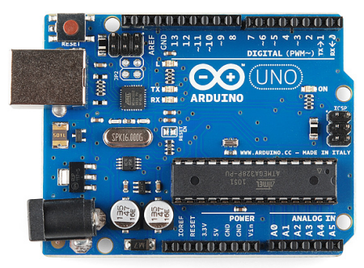 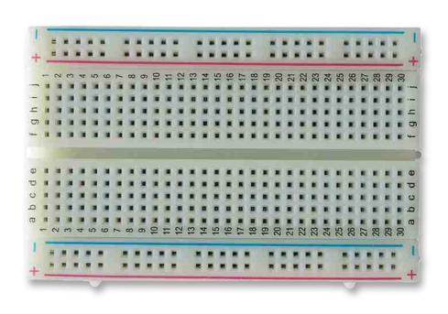

Breadboard

Arduino UNO

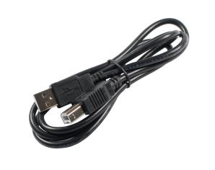 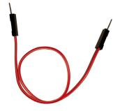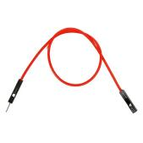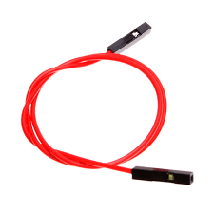 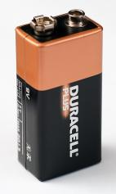

Jumper wires (M-M, M-F & F-F)

9V Battery

USB Cable

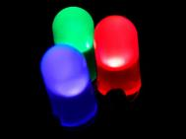  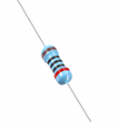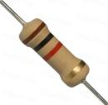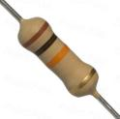 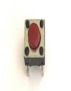

Push Botton

Resistors

RGB LED

LEDs

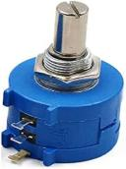 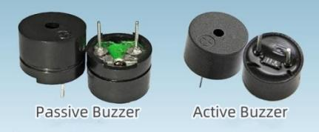 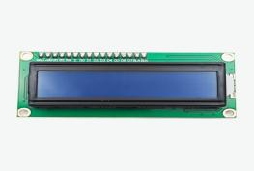

16x2 LCD display

Buzzers

Potentiometer

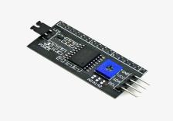 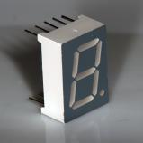 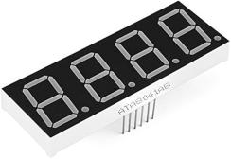 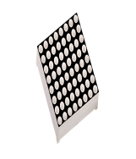

8x8 dot matrix display

4x7-segment display

7-segment display

I2C Serial Adapter

board module

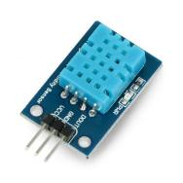 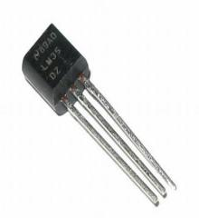 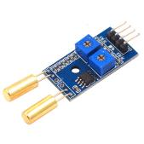

Tilt sensor

LM35 Temperature Sensor

Temperature and humidity sensor (DHT11)

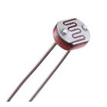 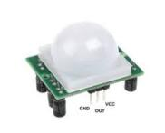 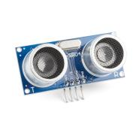 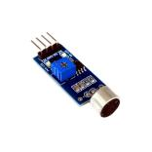

Sound sensor

Ultrasonic module

PIR sensor

Photoresistor

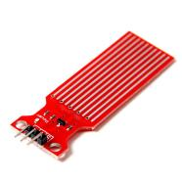 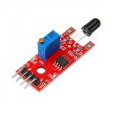 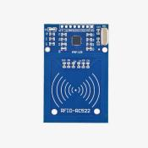 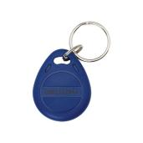

RFID tag

RFID module

Flamesensor

Water sensor

 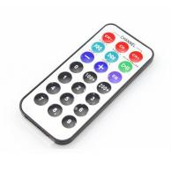 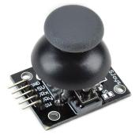 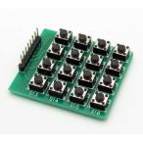

4x4 Matrix Keyboard Module

Joystick module

Infrared remote control

Infrared receiver

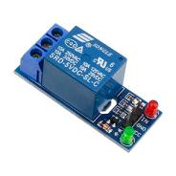 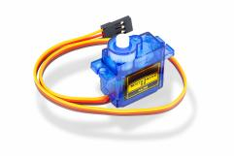 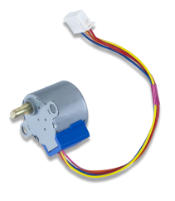 

Stepper motor driver board

Stepper motor

Servo motor

Relay module

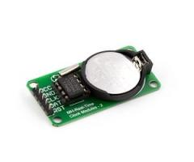 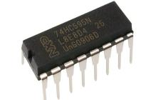

74HC595 Chip

Real-time Clock Module DS1302

**Schematic Diagram**

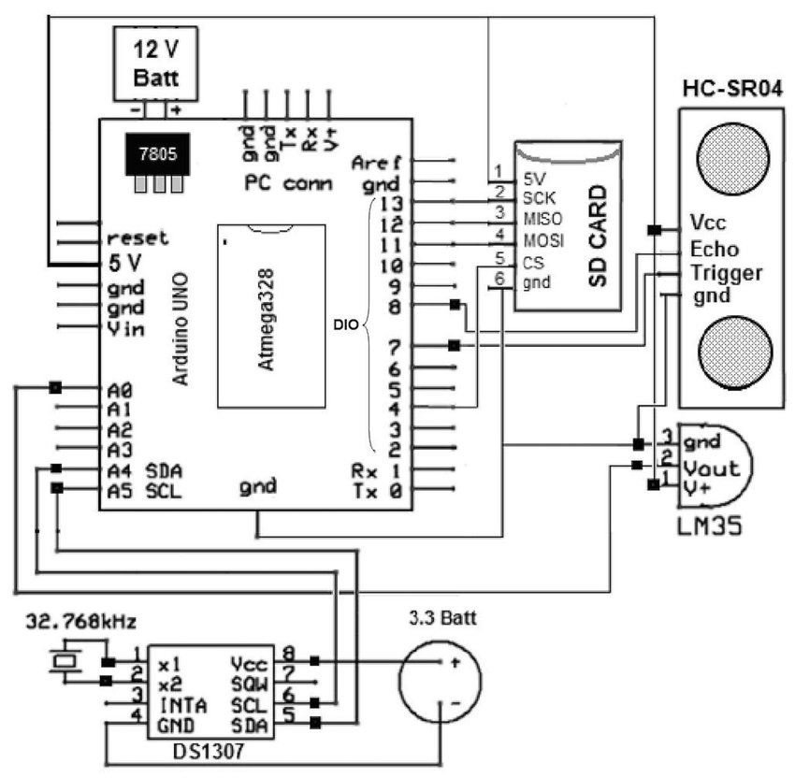

This schematic diagram shows an **Arduino-based data logging system** that measures **temperature** and **distance**, keeps **real-time clock (RTC)** data, and stores all readings onto an **SD card**.  
Let’s explain each part step-by-step:

1. **Main Controller: Arduino Uno (ATmega328)**

* Acts as the **brain** of the system.
* Controls sensors, reads data, and logs it into the SD card.
* Powered by a **12V battery** through a **7805 voltage regulator** (provides a stable 5V output).
* **Key pins used:**

**- A0–A5:** Analog and I²C communication pins.

**- D8–D13:** Digital I/O used for the SD card and ultrasonic sensor.

1. **Power Supply Section**

* **12V Battery** → provides main power.
* **7805 Voltage Regulator** → converts 12V → 5V DC for Arduino and sensors.
* **3.3V Battery** (for DS1307 RTC) → keeps time even when the main power is off.

### **LM35 – Temperature Sensor**

* Connected to **Analog pin A0**.
* Outputs a voltage proportional to temperature (10 mV per °C).
* Pin connections:

**- V+** → 5V

**- Vout** → A0 (analog input)

**- GND** → GND

### **HC-SR04 – Ultrasonic Distance Sensor**

* Measures distance by sending and receiving ultrasonic waves.
* Connected to Arduino digital pins:

**- Trigger** → D9

**- Echo** → D8

**- Vcc** → 5V

**- GND** → GND

* Arduino calculates distance using the time delay between sent and received pulses.

### **DS1307 – Real-Time Clock (RTC) Module**

* Keeps track of **date and time**.
* Communicates with Arduino via **I²C**:

**- SDA** → A4

**- SCL** → A5

* Has a **32.768 kHz crystal oscillator** for accurate timing.
* Powered by a **3.3V battery** to maintain time when Arduino is off.

### **SD Card Module**

* Used for **data logging** (storing sensor readings with timestamps).
* Connected via **SPI communication**:

**- MOSI** → D11

**- MISO** → D12

**- SCK** → D13

**- CS (Chip Select)** → D10

**- VCC** → 5V

**- GND** → GND

### **How It Works (System Function)**

1. **Arduino** reads:

* Temperature from **LM35**.
* Distance from **HC-SR04**.
* Current date & time from **DS1307**.

1. Combines these readings into a single line of data.
2. **Saves** the data to the **SD card** in a text or CSV file (like data.txt).
3. The process repeats continuously at a set time interval.

### ****Example of Logged Data (on SD Card)****

| **Date** | **Time** | **Temperature (°C)** | **Distance (cm)** |
| --- | --- | --- | --- |
| 29/10/2025 | 08:00:00 | 27.5 | 123 |
| 29/10/2025 | 08:05:00 | 27.7 | 122 |

### ****Summary of Components and Roles****

| **Component** | **Function** |
| --- | --- |
| ****Arduino Uno**** | Main controller, processes and logs data |
| ****7805 Regulator**** | Converts 12V → 5V |
| ****LM35**** | Measures temperature |
| ****HC-SR04**** | Measures distance |
| ****DS1307 RTC**** | Provides real-time clock |
| ****SD Card Module**** | Stores sensor data |
| ****12V Battery**** | Main power supply |
| ****3.3V Battery**** | RTC backup power |